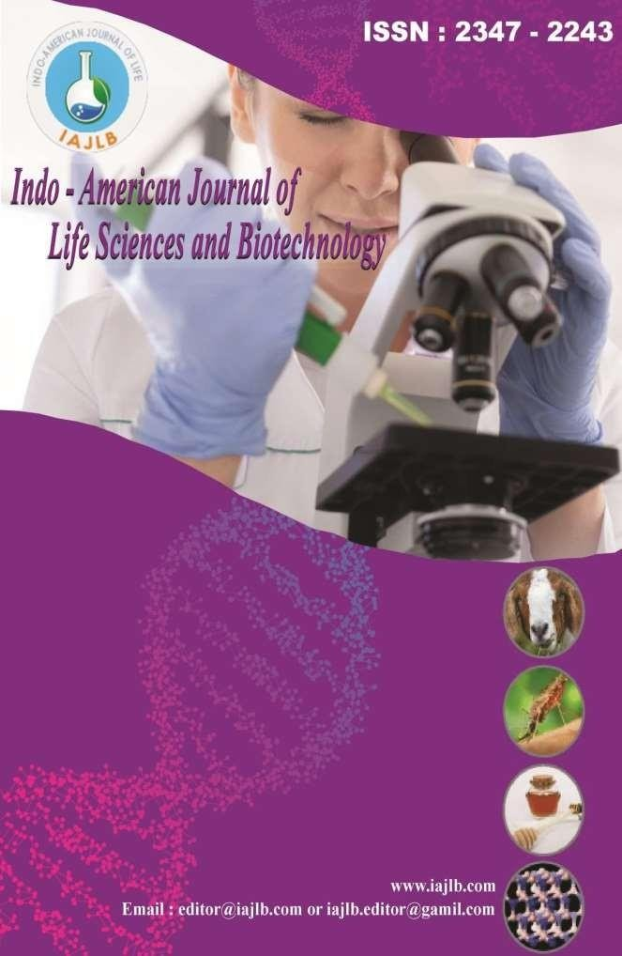

Acute Respiratory Syndrome and Parasitic In Vitro Effects of Pouteria alnifolia Extracts and Fractions on Coronavirus Type 2 Activity
K. Madhusudhan, K. Anitha
1Department of Chemistry, School of Physical and Mathematical Sciences, University of Ghana
2West African Centre for Cell Biology of Infectious Pathogens, University of Ghana
Abstract:

Background: Herbal medicine is popular all across the globe, including in tropical Africa, but there isn't a ton of research to back up claims about its safety and effectiveness. Pouteria alnifolia was the subject of this investigation because of its possible use as a substitute anti-infective. The methods used in this study included bioactivity-guided isolation of P. alnifolia extracts from various parts of the plant, and the determination of the fractions' and extracts' cytotoxicity, anti-SARS-CoV-2, antitrypanosomal, and antileishmanial properties in vitro using the alamarBlue assay. Microscopical analysis of cell counts after parasite exposure to varying concentrations of chosen extracts and fractions allowed researchers to deduce the growth kinetics of Trypanosoma brucei brucei. While no anthracene or anthraquinone derivatives were detected in any of the fractions that were analyzed, the most prevalent phytochemicals found in these fractions were cardiac glycosides and terpenoids. In contrast to the butanol (BuOH) portions of the fruit pulp, stem, and roots, the dichloromethane (DCM) extracts of the seeds and whole fruit (WF) also included alkaloids. Leishmania donovani had IC50 values ranging from 1.3 ± 0.1 to 27.8 ± 1.8 μg/mL, while T. b. brucei had values between 07 ± 0.0 and 59.5 ± 0.3 μg/mL. BuOH fractions from seeds and WFs were particularly potent against SARS-CoV-2, whereas DCM extracts from stem, seeds, and WFs reduced the development of T. b. brucei. Conclusion: P. alnifolia extracts and fractions show promise as chemotherapeutic agents for a range of tropical African illnesses; additional research is needed to confirm this.

Introduction

Herbal remedies for infectious diseases are an integral component of African healthcare systems, particularly in areas where conventional pharmaceuticals are scarce. Many of these herbal remedies have their origins in the collected wisdom of the people who have traditionally used them. Many plant remedies are used often, however there is still a lack of thorough scientific confirmation on their safety and effectiveness. 1 and 2
The alnifolia peouteria The Sapotaceae family of plants includes Roberty Bak. More than 300 species make up the Pouteria genus; they are most often found in the tropics and subtropics of South America, Africa, and Asia. Three, four Ghanaians name P. alnifolia "asamfona" because the fruit and oil extracted from the seeds are palatable. Pouteria alnifolia is one of many species in the genus Pouteria that have traditional medicinal uses, including the treatment of wounds, conjunctivitis, diarrhea, ulcers, and yaws, among other infectious disorders. [5] A thorough investigation of P. alnifolia's anti-infective and other in vitro characteristics is necessary due to its extensive traditional usage.

African trypanosomiasis (sleeping sickness) and leishmaniasis are two Neglected Tropical Diseases (NTDs) caused, respectively, by Trypanosoma brucei and Leishmania donovani. Treatment for these NTDs is over-reliant on a few drugs that are associated with severe toxicity and drug resistance and run the risk of giving rise to drug-induced resistance.^{[6,7]} In addition, severe acute respiratory syndrome coronavirus 2 (SARS-CoV-2), the causative agent of COVID-19, continues to inflict people in West Africa, where full availability of SARS-CoV-2 vaccines has not been achieved.^{[8,9]} Of particular importance is the impact of comorbidities of infections such as SARS-CoV-2 coupled with co-infections with diseases such as African trypanosomiasis and leishmaniasis, which may influence clinical outcomes and complicate management.^{[10,11]} Thus, any natural product or medicinal plant extract/fraction with broad-spectrum anti-infective activity may have an additional benefit of targeting multiple pathogens that makeup coinfections. In this study, the in vitro antitrypanosomal, antileishmanial, and anti-SARS-CoV-2 activities of extracts and fractions from different parts of P. alnifolia including the leaves, whole fruits (WFs), seeds, fruit pulps (FPs), stem bark, and roots were investigated.

Methods
All solvents used were of analytical grade. Organic solvents used included hexane (H), petroleum ether (P), chloroform (CHCl₃), ethyl acetate (EtOAc), butanol (BuOH), ethanol (EtOH), and methanol (MeOH). Cold percolation was used for the extraction of the pulverized plant material. Evaporation of solvents from extracts was done under pressure using a Cole-Parmer Rotary Evaporator (Vernon Hills, Illinois), and the solvents recovered were re-used in the subsequent extractions.

Ethical considerations
In this study, extracts and fractions of P. alnifolia plant parts were used against the experimental microbes,
Trypanosoma brucei brucei, L. donovani, and SARS-CoV-2. Ethical approval was obtained from the University of Ghana Institutional Animal Care and Use Committee (UG-IACUC) with approval number UG-IACUC 006/21-22. The study did not involve any human subjects; hence, human ethical considerations were not applicable.

Type of sampling and reasons for selection
Random sampling was used in this study. The protozoan parasites, human monocytic cell line (THP-1), and SARS-CoV-2 were cultured, and growing cells with good morphological features were used for the inhibitory and cytotoxicity assays.

Inclusion criteria
Experimental microbes and human monocytic cell line (THP-1) were appropriately cultured, and those with >90% viability were used in the assays.

Exclusion criteria
Protozoan parasites, SARS-CoV-2, and human monocytic cell line (THP-1) cultures with <90% viability were not used in the assays.

Data availability statement
The data supporting the findings of this study are available
within the article and its supplementary materials.
Extraction and fractionation of Pouteria alnifolia plant parts
After plants collection [Supplementary File], extraction and fractionation of the six plant part materials were carried out based on the modified Kupchan method as described by Dofuor et al.^{[12]} An amount of 560 g of the pulverized WFs and 565 g of seeds (S) were each repeatedly extracted with 5 L of 70% EtOH, whereas 450 g of the FP was extracted with 4 L of 70% EtOH at room temperature [Table 1]. Each plant material was filtered after 48 h and the solvent was removed in vacuo to give concentrates coded as 70% ethanol of P. alnifolia whole fruit (PAWF), 70% ethanol of
P. alnifolia seeds (PAS), and 70% ethanol of P. alnifolia fruit pulp (PAFP). In a similar manner, 1.7 kg of the stems (St), 550 g of the leaves (L), and 2.4 kg of the roots (R) were also each extracted in 5 L, 2 L, and 10 L of 70% EtOH, respectively. Evaporation of each extract gave the 70% ethanol of P. alnifolia leaf extract (PAL), 70% ethanol of P. alnifolia stem extract (PASt), and 70% ethanol of
P. alnifolia root extract (PAR).

Table 1: Preparation of plant parts
Part of P. alnifolia | Mass(g) | Volume of 70% Ethanol (L) | Extract code | Code interpretation
Whole fruits | 560 | 5 | PAWF | 70% ethanol of P. alnifolia whole fruit
Seeds | 565 | 5 | PAS | 70% ethanol of P. alnifolia seeds
Fruit pulp | 450 | 4 | PAFP | 70% ethanol of P. alnifolia fruit pulp
Leaves | 1700 | 5 | PAL | 70% ethanol of P. alnifolia leaf
Stem bark | 550 | 5 | PASt | 70% ethanol of P. alnifolia stem
Roots | 2400 | 10 | PAR | 70% ethanol of P. alnifolia roots
P. alnifolia: Pouteria alnifolia

Fractionation of extracts from PAWF, PAS, PAFP, PAL, PASt, and PAR of Pouteria alnifolia
Each of the six 70% EtOH extracts (PAWF, PAS, PAFP, PAL, PASt, and PAR) was reconstituted in 10% aqueous EtOH and successively partitioned with 1.5 L of hexane (H) or petroleum ether (P), dichloromethane (DCM) (D) or CHCl₃ (C), EtOAc (E), and BuOH (B). The remaining aqueous fractions (aq) were freeze-dried. Example, the fractions obtained from the 70% EtOH extract of P. alnifolia whole fruit (PAWF) were coded as PWFH (hexane fraction from PAWF), PWFD (DCM fraction from PAWF), PWFE (EtOAc fraction from PAWF), PWFB (BuOH fraction from PAWF), andaqueous fractions from PAWF (PAWFaq). Fractions from the 70% EtOH extract of P. alnifolia seeds (PAS) extract were also coded accordingly as hexane fraction from PAS (PSH), DCM fraction from PAS (PSD), EtOAc fraction from PAS (PSE), BuOH fraction from PAS (PSB), and aqueous fraction from PAS (PASaq), whereas the fractions from the PAFP extract included PFPH, PFPD, PFPE, PFPB, and aqueous fraction from PAFP (PAFPaq). In a similar manner, fractions obtained after the partitioning of the PAL extract were coded as PLH, PLD, PLE, PLB, and PALaq, those of PASt extract are PStH, PStD, PStE, PStB, and PAStaq and finally from the PAR extract gave PRP, PRC, PRE, PRB, and aqueous fraction from PAR (PARaq) fractions [Figure 1].

In vitro antitrypanosomal and antileishmanial activities and cytotoxicity assay
The alamarBlue assay was used to determine the effect of extracts
and fractions on T. b. brucei GUTat 3.1 bloodstream forms and
L. donovani (MHOM/SD/62/1S) promastigotes as described previously.^{[12-14]} For the T. b. brucei GUTat 3.1 parasites, the extracts and fractions were serially diluted (range 0–100 μg/mL) into a Costar flat bottom 96‑well plate using HMI‑9 media. Afinal parasite concentration of 4000 cells (100 μL) was added to each well and the plates were incubated in 5% CO₂ for 72 h at 37°C.
L. donovani promastigotes (2 × 10⁵ cells) were grown for 72 h at 25°C in freshly made M-199 medium either without or with varying concentrations of the extracts and fractions (0–100 μg/ mL). To determine the cytotoxicity of extracts and fractions THP-1 cells were grown at 1 × 10⁵ cells/mL in two series of passages in freshly prepared RPMI 1640 media supplemented with 10% FBS and 100 μg/mL penicillin/streptomycin. In a Costar flat bottom 96‑well plate, THP‑1 cells were treated with varying concentrations of the extracts or fractions (0– 100 μg/mL). The plates were incubated in 5% CO₂ for 72 h at 37°C. A final concentration of resazurin sodium salt (44
μM) (Sigma‑Aldrich, USA) prepared in phosphate‑buffered saline was added to each well, and the different plates were incubated accordingly for a further 5 h. The Varioskan Lux Elisa plate reader (Thermo Scientific) was used to measure the absorbance at 570 nm. The absorbances obtained were extracted into GraphPad Prism (version 6) (GraphPad Software, Boston, Massachusetts, USA) and the half-maximal inhibitory concentrations (IC50) values were determined. The IC50 reported
for the extracts and fractions is the mean from three independent
experiments. Diminazene aceturate, a known antitrypanosomal drug, and Amphotericin B, a known antileishmanial drug were used as positive controls. The CC₅₀ reported is the mean from three independent experiments. Selectivity indices (SI) were then estimated as the ratio of the CC50 to IC50 values.

Antiviral activity of fractions of plant parts
Vero-E6 cells were obtained from the American Tissue Culture Collection and cultured in D10+ medium (Dulbecco’s modified Eagle medium) with 4.5 g/L glucose and L-glutamine (Gibco, Gaithersburg, MD, USA), 10% fetal bovine serum (Gemini Bio-Products, West Sacramento, CA, USA), and 100 μg/mL streptomycin (Sigma-Aldrich, St. Louis, MO, USA) in a humidified incubator at 37°C and 5% CO₂. The following reagent was deposited at the Centers for Disease Control and Prevention and obtained through BEI Resources, NIAID, NIH: SARS-related coronavirus 2, isolate USA-WA1/2020, NR-52281. Virus stocks for infection studies were performed as described previously.^{[15]}
For viral infection assays, Vero‑E6 cells were first plated in D10+ at 10⁵ cells/mL in 96-well format, treated with plant extracts, fractions, or remdesivir control (Sigma-Aldrich) at desired concentrations in 3-fold replicates, and incubated for 2 h. Following incubation, cells were infected with 150x TCID50 of the virus and incubated for an additional 96 h. Cells were then treated and incubated with 20 μg/mL of resazurin (Sigma-Aldrich) for 4 h and then fixed with paraformaldehyde to a final concentration of 4% at room temperature for 30 min to inactivate virus. Fluorescence intensity was measured using a ClarioStar microplate reader (BMG Lab Tech, Cary, NC, USA). Fluorescence intensities were normalized such that uninfected cell controls on each plate were denoted as 100% viability, while infected cells without extract, fractions, or drug treatment were denoted as 0% viability.
For cell viability assays, experiments were performed as described except for no virus infection. Fluorescence intensities were normalized such that untreated cell controls on each plate were denoted as 100% viability, whereas wells with D10+ medium only were denoted as 0% viability. All data are presented as the mean ± standard deviation (SD) from at least two independent experiments.

Statistical analysis
All experimental data were generated from at least two to three independent experiments, each performed in triplicate unless otherwise stated. Quantitative results are presented as mean ± SD. For the determination of inhibitory concentrations (IC₅₀) and cytotoxic concentrations (CC₅₀), dose– response curves were plotted using GraphPad Prism (version 6). Nonlinear regression analysis (log [inhibitor] vs. normalized response – Variable slope) was used to fit the data and the IC₅₀ and CC₅₀ values for each extract and fraction were calculated. For the anti-parasitic and cytotoxicity assays, the percentage inhibition or cell viability was calculated relative to untreated controls, which were set at 100%. For the anti-SARS-CoV-2 assays, fluorescence intensities were normalized such that

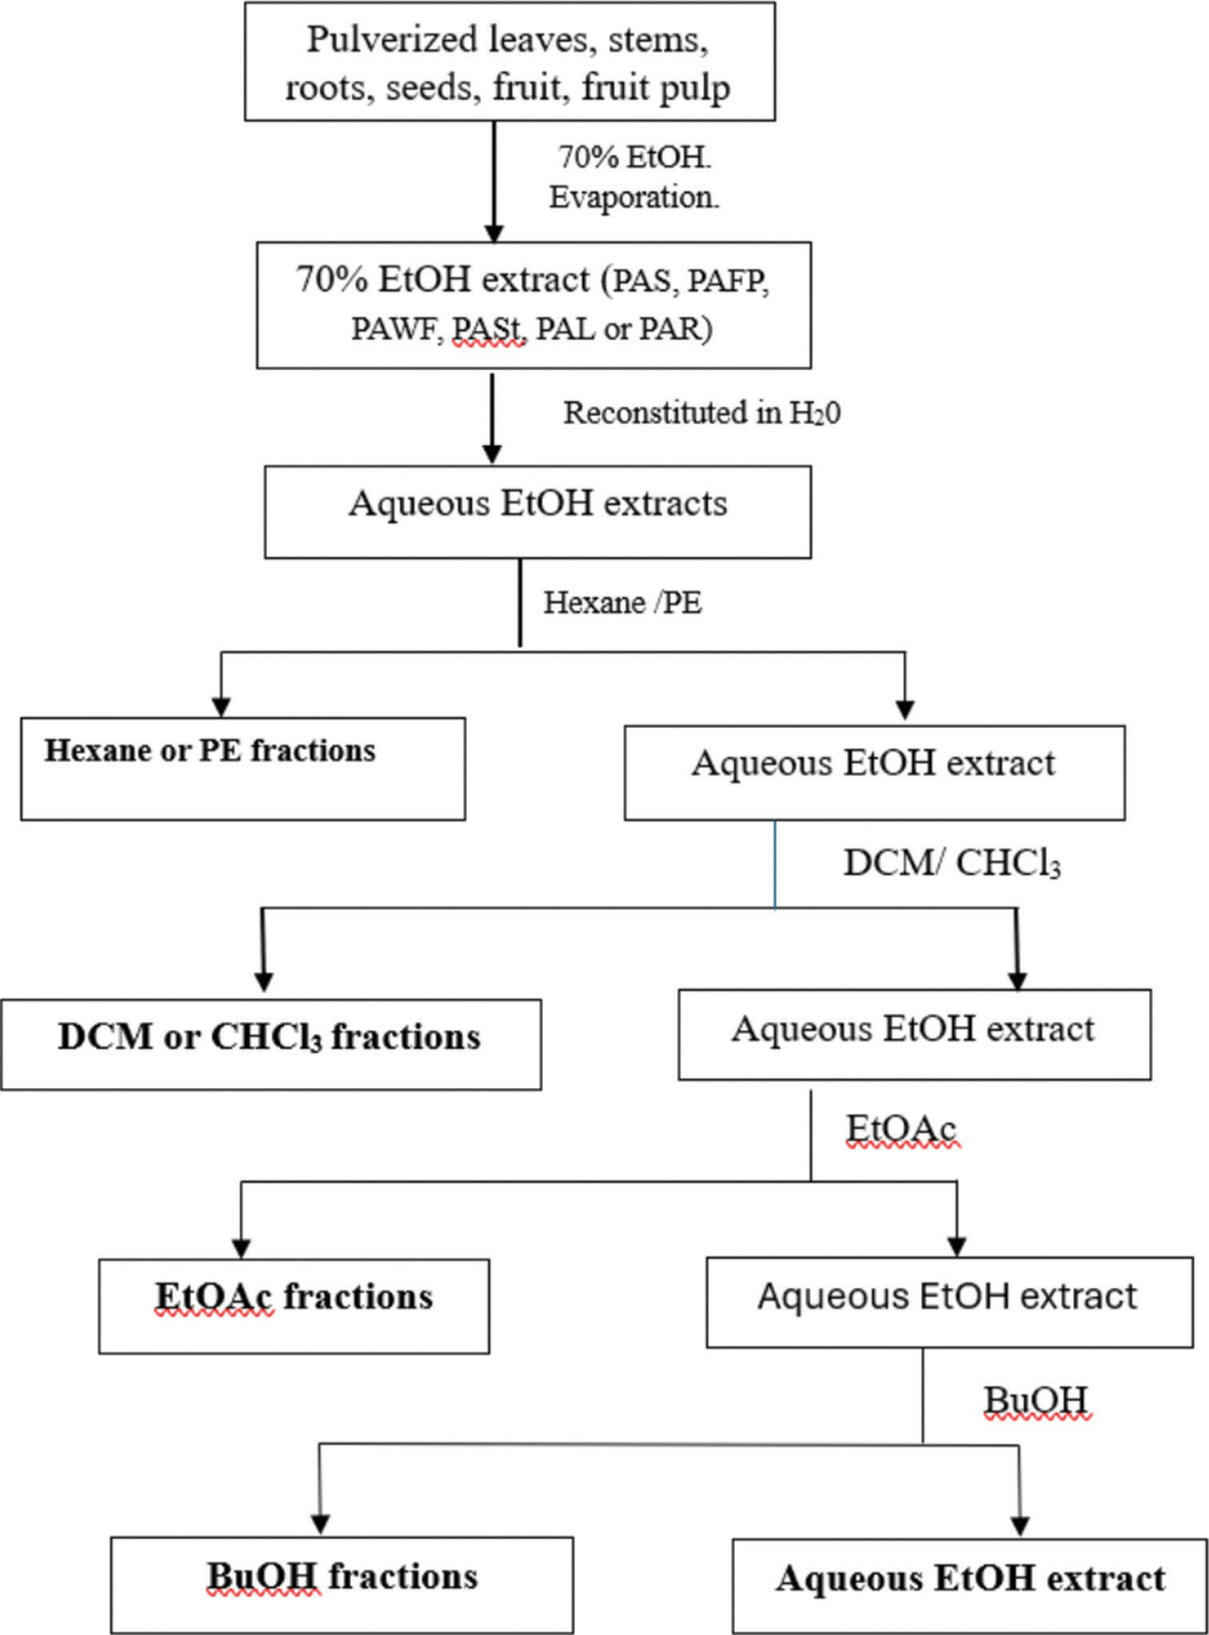
Figure 1: Scheme for the extraction and fractionation of leaves, stems, roots, and fruits of Pouteria alnifolia plant parts. PAL: 70% EtOH P. alnifolia
leaf extract, PASt: 70% EtOH P. alnifolia stem extract, PAR: 70% EtOH P. alnifolia root extract, PAS: 70% EtOH P. alnifolia seed extract, PAFP: 70% EtOH
P. alnifolia fruit pulp extract, PAWF: 70% EtOH P. alnifolia whole fruit extract

uninfected cell controls represented 100% viability and infected, untreated controls represented 0% viability. SI was calculated as the ratio of CC₅₀ to IC₅₀ for each extract or fraction. Where comparisons between multiple extracts or fractions were required, one-way analysis of variance was performed followed by Tukey’s post hoc test to determine statistically significant differences between groups. A P < 0.05 was considered statistically significant. All statistical analyses and graphical representations were performed using GraphPad Prism (version 6). The results are reported as mean ± SD, and detailed data were available in the supplementary materials.

Data availability statement
The data are available from the corresponding author and will be shared upon reasonable request.

Results
Screening of Pouteria alnifolia stems, leaves, and roots fractions revealed the presence of various phytochemicals Different phytochemical screening tests were used to determine the presence of phytochemicals in the different parts of P. alnifolia [Tables 2, 3 and Supplementary File]. Of the 24

fractions tested, terpenoids constituted the most abundant and were present in all fractions except the EtOAc fraction of the leaves (PLE) and BuOH fractions of both the whole fruit (PWFB) and fruit pulp (PFPB). Cardiac glycosides were also present in all the fractions of the leaves, stems, roots, and seeds but were absent from the FP and the hexane, and DCM fractions of the WF [Tables 2-4]. Anthracene and anthraquinone derivatives were not detected in all the fractions except in the hexane extract of the stem, PStH [Table 2]. Saponins were present in only five of the 24 fractions [Table 3]. Tannins were found in some of the stem fractions (PStD, PStE, and PStB) and the FP (PFPD, PFPE) as well as in PSE, PRE, and PWFE fractions [Tables 2 and 3].
Flavonoids were present in all fractions of the FP and some fractions of the WF, stem, and roots. Phenols were present in some fractions of the stem (PStD, PStB) and FP (PFPD and PFPE) [Tables 2 and 3] as well as in PSE, PRE, and PWFD. Alkaloids were present in the hexane and DCM extracts of the seeds and the WF as well as in the EtOAc and BuOH fractions of the FP, stem, and roots [Tables 2 and 3]. Cardiac glycosides and terpenoids were present in the PLH, PLD, and PLB. Only PStH showed the presence of anthracene and anthraquinones derivatives [Table 2]. Apart from
anthracene and anthraquinone derivatives, all the other tested phytochemistry were present in PStD and PStB [Tables 2-4].

Extracts have potent antitrypanosomal and antileishmanial activities
In vitro activities of P. alnifolia plant parts were determined on
T. b. brucei, L. donovani, and THP-1 cells using the alamarBlue assay. The absorbances obtained were used to calculate the half-maximal inhibitory concentrations (IC₅₀) values for each of the extracts and fractions [Tables 5 and 6]. Thirty-eight extracts and fractions were tested against T. b. brucei and 10 extracts and fractions were tested against L. donovani. The IC₅₀ values for T. b. brucei were between 07 ± 0.0 and
59.5 ± 0.3 μg/mL, whereas that of L. donovani ranged from
1.3 ± 0.1 to 27.8 ± 1.8 μg/mL with PRP having the best antitrypanosomal activity [Table 5]. Ten out of 23 extracts and fractions tested (43.5%) showed SI of >10, indicating good selectivity against the trypanosome parasites.
Anti-leishmanial activity was done on 10 extracts and fractions that showed promising antitrypanosomal activity and SI. Of these PWFB, PWFD, PWFE, and PWFH of WF showed the best antileishmanial activities with IC₅₀ values of
1.3 ± 0.1–1.6 ± 0.1 (μg/ml) and SI of 17.1–157.0 [Table 6]. DCM

Table 2: Phytochemical screening of Pouteria alnifolia stem and leaves
Phytochemicals PASt P. alnifolia leaves
 | PStH | PStD | PStE | PStB |  | PLH | PLD | PLE | PLB
Saponins | – | + | – | + |  | – | – | – | –
Tannins | – | + | + | + |  | – | – | – | –
Flavonoids | – | + | – | + |  | – | – | – | –
Phenols | – | + | – | + |  | – | – | – | –
Terpenoids | + | + | + | + |  | + | + | – | +
Alkaloids | – | + | + | + |  | – | – | – | –
Cardiac glycosides | + | + | + | + |  | + | + | + | +
Anthracene and anthraquinones | + | – | – | – |  | – | – | – | –
+: Means present, –: Means not present. P. alnifolia: Pouteria alnifolia, PASt: 70% EtOH P. alnifolia stem extract, PStH: Hexane fraction from PASt. PStC: CHCl₃ fraction from PASt, PStD: DCM fraction from PASt, PStE: EtOAc fraction from PASt, PStB: BuOH fraction from PASt, PASt aq: Aqueous fraction from PASt after partitioning, PLH: Hexane fraction from P. alnifolia leaf, PLD: DCM fraction from P. alnifolia leaf, PLE: EtOAc fraction from P. alnifolia leaf, PLB: BuOH fraction from P. alnifolia leaf, PALaq: Aqueous fraction from PAL after partitioning
Table 3: Phytochemical screening of Pouteria alnifolia roots and fruit pulp
Phytochemicals P. alnifolia roots P. alnifolia fruit pulp
 | PRP | PRC | PRE | PRB |  | PFPH | PFPD | PFPE | PFPB
Saponins | – | – | – | – |  | – | – | – | +
Tannins | – | – | + | – |  | – | + | + | –
Flavonoids | – | + | + | + |  | + | + | + | +
Phenols | – | – | + | – |  | – | + | + | –
Terpenoids | + | + | + | + |  | + | + | + | –
Alkaloids | – | – | + | + |  | – | – | + | +
Cardiac glycosides | + | + | + | + |  | – | – | – | –
Anthracene and anthraquinones | – | – | – | – |  | – | – | – | –
+: Means present, –: Means not present. PAR: 70% EtOH P. alnifolia root extract. PRP: Petroleum ether fraction from PAR, PRC: CHCl₃ fraction from PAR, PRE: EtOAc fraction from PAR, PRB: BuOH fraction from PAR, PARaq: Aqueous fraction from PAR after partitioning, PAFP: 70% EtOH
P. alnifolia fruit pulp extract, PFPH: Hexane fraction from PAFP, PFPD: DCM fraction from PAFP, PFPE: EtOH fraction from PAFP, PFPB: BuOH fraction from PAFP, PAFPaq: Aqueous fraction from PAFP after partitioning

Table 4: Phytochemical screening of Pouteria alnifolia seeds and whole fruit
Phytochemicals P. alnifolia seeds P. alnifolia whole fruit
 | PSH | PSD | PSE | PSB |  | PWFH | PWFD | PWFE | PWFB
Saponins | – | – | + | – |  | – | – | + | –
Tannins | – | – | + | – |  | – | – | + | –
Flavonoids | – | – | + | – |  | + | + | + | –
Phenols | – | – | + | – |  | – | + | – | –
Terpenoids | + | + | + | + |  | + | + | + | –
Alkaloids | + | + | – | – |  | + | + | – | –
Cardiac glycosides | + | + | + | + |  | – | – | + | +
Anthracene and anthraquinones | – | – | – | – |  | – | – | – | –
+: Means present, –: Means not present. PAS: 70% EtOH P. alnifolia seed extract, PSH: Hexane fraction from PAS, PSD: DCM fraction from PAS, PSE: EtOAc fraction from PAS, PSB: BuOH fraction from PAS. PASaq: Aqueous fraction from PAS after partitioning, PAWF: 70% EtOH P. alnifolia whole fruit extract, PWFH: Hexane fraction from PAWF, PWFD: DCM fraction from PAWF, PWFE: EtOAc fraction from PAWF. PWFB: BuOH fraction from PAWF, PAWFaq: Aqueous fraction from PAWF after partitioning

Table 5: Mean antiparasitic activities and selectivity indices of Pouteria alnifolia extracts and fractions of the roots, seeds, and stem against Trypanosoma brucei brucei and Leishmania donovani promastigotes
Plant part extract | Fraction code | IC₅₀±SD (µg/mL)  for T. b. brucei | CC₅₀±SD (µg/mL)  THP‑1 cells | SI (CC50/IC50)  T. b. brucei | IC50±SD (µg/mL)  for L. donovani | SI (CC50/IC50)  L. donovani
Roots | PAR | 45.0±6.5 | NA | NA | NA | NA
(PAR) | PRP | 0.7±0.0 | NA | NA | NA | NA
 | PRC | 18.3±1.2 | 345.6±28.6 | 18.9 | NA | NA
 | PLE | 42.2±1.9 | NA | NA | NA | NA
 | PRB | 26.3±1.9 | NA | NA | NA | NA
 | PRAaq | 59.5±0.3 | NA | NA | NA | NA
Seeds | PAS | 46.4±1.9 | NA | NA | NA | NA
(PAS) | PSH | 33.2±2.8 | 124.3±7.0 | 3.7 | NA | NA
 | PSD | 17.3±1.2 | 183.6±6.5 | 10.6 | NA | NA
 | PSE | 28.9±1.1 | 163.9±9.2 | 5.7 | NA | NA
 | PSB | 28.3±0.7 | 215.5±9.5 | 7.6 | NA | NA
 | PASaq | 28.1±1.7 | NA | NA | NA | NA
Stems | PASt | 6.7±0.9 | 137.1±21.2 | 20.6 | NA | NA
(PASt) | PStH | 23.2±0.8 | 69.6±2.2 | 3.0 | 7.1±0.5 | 9.9
 | PStP | 21.1±5.4 | 126.2±7.7 | 6.0 | NA | NA
 | PStD | 3.7±1.3 | 100.0±4.8 | 27.0 | 10.0±0.5 | 10.0
 | PStC | 4.6±0.2 | 85.6±3.3 | 18.7 | NA | NA
 | PStE | 27.2±1.1 | 145.0±8.5 | 5.3 | 14.5±0.8 | 10.0
 | PStB | 33.1±6.2 | 157.2±21.1 | 4.8 | 15.7±2.1 | 10.0
 | PAStaq | 36.6±2.8 | NA | NA | NA | NA
Diminazene Aceturate standard, IC₅₀ for T. b. brucei=0.1±0.0 μM, Amphotericin B standard, IC₅₀ for L. donovani=6.6±0.1 µM. Three independent experiments were performed, and data were expressed as mean±SD. Antitrypanosomal drug (positive control), amphotericin B: Antileishmanial drug (positive control). IC₅₀: 50% inhibitory concentration, SD: Standard deviation, CC₅₀: 50% cytotoxic concentration, NA: Not available, PAR: 70% EtOH
P. alnifolia root extract, PRP: Petroleum ether fraction from PAR, PRC: CHCl₃ fraction from PAR, PRE: EtOAc fraction from PAR, PRB: BuOH fraction from PAR. PARaq aqueous fraction from PAR after partitioning. PAS: 70% EtOH P. alnifolia seed extract. PSH: hexane fraction from PAS, PSD: DCM fraction from PAS, PSE: EtOAc fraction from PAS, PSB: BuOH fraction from PAS, PAS aq: aqueous fraction from PAS after partitioning, PASt: 70% EtOH
P. alnifolia stem extract, PStH: Hexane fraction from PASt, PStC: CHCl₃ fraction from PASt, PStD: DCM fraction from PASt, PStE: EtOAc fraction from PASt, PStB: BuOH fraction from PASt, PASt aq: Aqueous fraction from PASt after partitioning, PStP: Petroleum ether fraction from PASt, DA: Diminazene Aceturate, SI: Selectivity index, L. donovani: Leishmania donovani, T. b. brucei: Trypanosoma brucei brucei, P. alnifolia: Pouteria alnifoli
extracts of stem and WFs showed activity and good selectivity for both trypanosomes and Leishmania [Tables 5 and 6].
Selected extracts inhibit the growth of Trypanosoma brucei brucei
To determine the effect of extracts and fractions on the growth rate of the parasite, T. b. brucei cells were incubated in the absence or presence of different concentrations of
6 selected extracts and fractions (IC50 and 2x IC50), and parasites were counted every 24 h for 96 h to determine the growth rate [Supplementary File]. An exponential growth was observed for untreated parasites, but there was a reduction in cell proliferation of parasites treated with increased concentration of extracts [Figure 2]. There was a drastic reduction in cell growth at 48 h for 2x IC₅₀ for PStD and a

Table 6: Mean antiparasitic activities and selectivity indices of Pouteria alnifolia fractions of the whole fruit, fruit pulp, and leaves against Trypanosoma brucei brucei and Leishmania donovani promastigotes
Plant part extracts | Fraction codes | IC₅₀±SD (µg/mL)  for T. b. brucei | CC50±SD (µg/mL)  THP‑1 cells | SI (CC50/IC50)  T. b. brucei | IC₅₀±SD (µg/mL)  for L. donovani | SI CC50/IC50)  L. donovani
Whole fruit | PAWF | 37.4±1.2 | NA | NA | NA | NA
(PAWF) | PWFH | 5.2±0.6 | 24.5±4.2 | 4.7 | 1.4±0.1 | 17.5
 | PWFD | 4.4±0.3 | 59.1±6.4 | 13.6 | 1.3±0.1 | 44.2
 | PWFE | 7.7±0.7 | 96.3±2.6 | 12.4 | 1.4±0.1 | 70.3
 | PWFB | 29.3±1.8 | 244.5±11.8 | 8.4 | 1.6±0.1 | 157.0
 | PAWFaq | 45.6±5.3 | NA | NA | NA | NA
Fruit pulp | PAFP | 38.6±23.9 | NA | NA | NA | NA
(PAFP) | PFPH | 14.8±0.5 | 49.0±4.3 | 3.3 | NA | NA
 | PFPD | 8.1±1.7 | 40.1±4.5 | 5.0 | NA | NA
 | PFPE | 28.5±7.1 | 104.8±9.1 | 3.7 | NA | NA
 | PFPB | 23.1±2.9 | 278.3±18.4 | 12.0 | 27.8±1.8 | 10.0
 | PFPaq | 47.9±8.6 | NA | NA | NA | NA
Leaves | PAL | 18.2±0.7 | 221.5±24.8 | 12.2 | NA | NA
(PAL) | PLH | 13.3±0.9 | 33.6±1.3 | 2.5 | 21.7±1.0 | 1.6
 | PLD | 10.8±0.8 | 117.3±4.3 | 10.8 | NA | NA
 | PLE | 47.9±3.3 | NA | NA | NA | NA
 | PLB | 53.1±1.6 | NA | NA | NA | NA
 | PALaq | 43.1±4.4 | NA | NA | NA | NA
Diminazene Aceturate standard, IC₅₀ for T. b. brucei=0.1±0.0 µM, amphotericin B standard, IC₅₀ for L. donovani=6.6±0.1 µM. Three independent experiments were performed, and data were expressed as mean±SD. DA: Antitrypanosomal drug (positive control), amphotericin B: antileishmanial drug (positive control). DA: Diminazene aceturate, IC₅₀: 50% inhibitory concentration, SD: Standard deviation, CC₅₀: 50% cytotoxic concentration, NA: Not available, PAWF: 70% EtOH P. alnifolia whole fruit extract, PWFH: Hexane fraction from PAWF, PWFD: DCM fraction from PAWF, PWFE: EtOAc fraction from PAWF, PWFB BuOH fraction from PAWF, PAWFaq: Aqueous fraction from PAWF after partitioning, PAFP: 70% EtOH P. alnifolia
fruit pulp extract, PFPH: hexane fraction from PAFP, PFPD: DCM fraction from PAFP, PFPE: EtOH fraction from PAFP, PFPB: BuOH fraction from PAFP, PAFPaq: Aqueous fraction from PAFP after partitioning, PAL: 70% EtOH P. alnifolia leaf extract, PLH: hexane fraction from PAL. PLD: DCM fraction from PAL, PLE: EtOAc fraction from PAL, PLB: BuOH fraction from PAL, PALaq: aqueous fraction from PAL after partitioning,
L. donovani: Leishmania donovani, T. b. brucei: Trypanosoma brucei brucei, P. alnifolia: Pouteria alnifolia

relatively more drastic reduction in cell densities at 72 h at 2x IC50 for PWFD. Treatment with IC50 concentrations of PWFE, PFPB, and PStC did not have any strong effect on cell proliferation [Figure 2].
Antiviral activities of fractions of Pouteria alnifolia
To assess whether plant fractions and extracts of P. alnifolia plant parts have antiviral properties, their inhibition of SARS-CoV-2 replication using an established assay that measures restoration of infected cell viability was done.^{[15]} SARS-CoV-2 infection in the absence of treatment reduced cell viability by 63.4 ± 7.0% (mean ± SD), whereas co-treatment with positive control 10 μM remdesivir restored cell viability (i.e. inhibited virus replication) by
87.0 ± 15.3%. Overall, 38 primary extracts and fractions from P. alnifolia plant parts were screened and six (15.8%) which restored at least 10% cell viability at 25 μg/mL were identified. These extracts included PWFB, aqueous (PASaq), and BuOH (PSB) fractions of seeds, hexane (PStH) and PE fractions of the stem (PStP), and PE fraction of roots (PRP). The most active agent was PSB, which inhibited 73.7 ± 17.7% of SARS-CoV-2 replication at 12.5 μg/mL, followed by PWFB, which inhibited 67.2 ± 17.3% virus replication at 50 μg/mL [Figure 3a]. In uninfected Vero-E6 cells treated with fractions for 96 h in parallel, no major effects on viability (i.e., >25% reduction relative to untreated cells) at
up to 50 μg/mL were observed, except for 50 μg/mL of PSB, which reduced cell viability by 50.0 ± 7.2% [Figure 3b].

Discussion
In this study, the antiparasitic and anti-viral potencies of extracts and fractions obtained from a medicinal plant,
P. alnifolia, commonly used to treat illnesses across many areas in Africa including Ghana are reported. When the kind of phytochemicals that were present in the different parts of the plant were analyzed, it was observed that while anthracene and anthraquinone derivatives were absent in all the tested fractions, terpenoids and cardiac glycosides were the most present phytochemicals in the fractions. The triterpenoids betulin and lupeol have been isolated from the stem of P. alnifolia, whereas the fatty acids tridecanoic acid, pentadecanoic acid octadecenoic (oleic) acid, heptadecanolide, and an unsaturated monoglyceride have been reported from the roots of P. alnifolia.^{[4]} Furthermore, triterpenoids such as betulinic acid and ursolic acid have been reported from some species of Pouteria including P. campechiana and
P. gardneri.^{[3,4,16,17]} The secondary metabolites obtained from the plant extracts might explain some of the reported biological activities of this plant. For example, while the phenolic compounds found in Pouteria extracts can explain the antioxidant and free radical scavenging activities, the

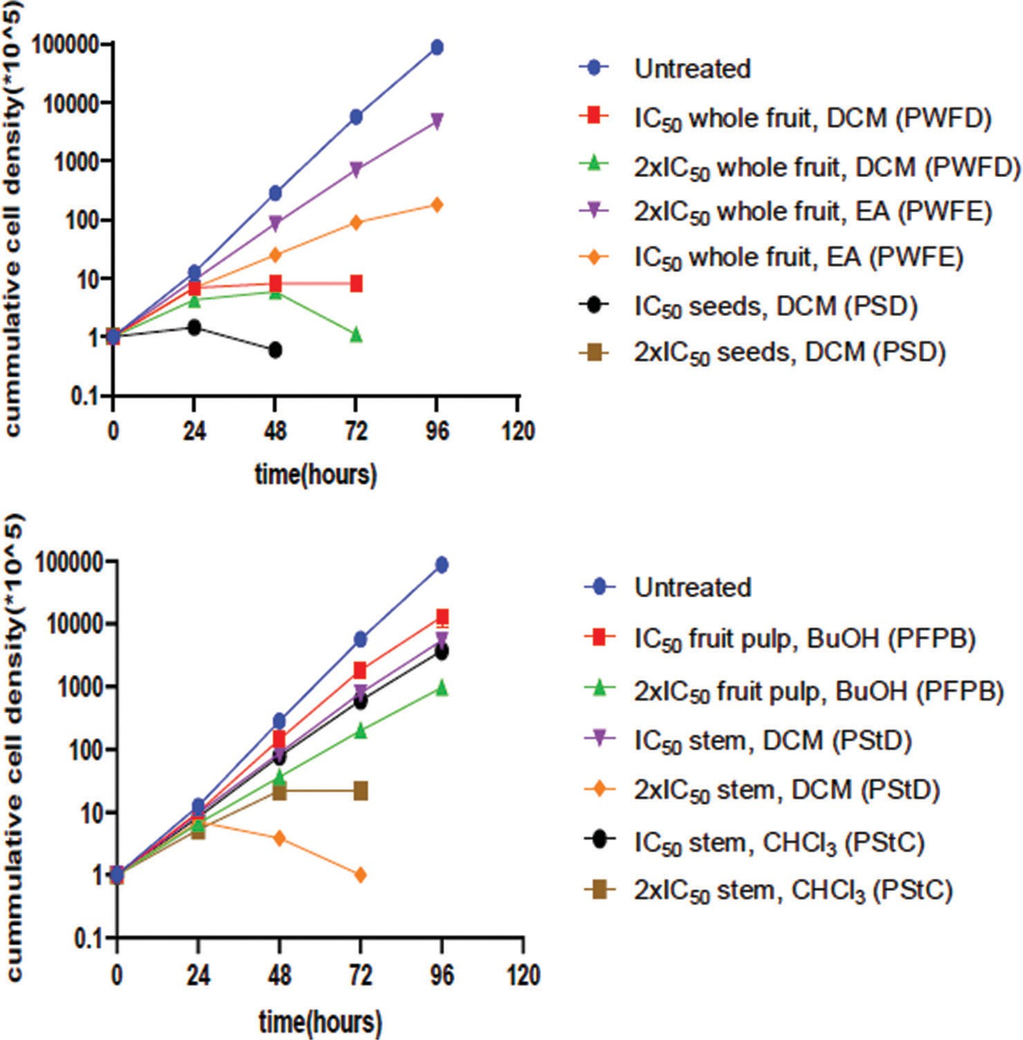

a

b
Figure 2: Selected extracts inhibit growth of Trypanosoma brucei brucei bloodstream forms. Trypanosomes were treated with individual extracts at IC₅₀ and 2x IC₅₀. The growth kinetic curve was determined by counting parasites every 24 h for 120 h. Data from three independent experiments are represented as mean ± standard deviation. The extracts shown were selected based on their good inhibitory activity and selectivity indices. NC: Untreated negative control, BuOH: Butanol, DCM: Dicloromethane, EA: Ethyl acetate, CHCl₃: Chloroform, PWFD: DCM fraction from PAWF, PWFE: EtOAc fraction from PAWF, PSD: DCM fraction from PAS, PFPB: BuOH fraction from PAFP, PStD: DCM fraction from PASt, PStC: CHCl3 fraction from PASt

presence of triterpenes has been shown to exhibit a protective effect by efficiently intercepting free radicals before they reach their biological targets.^{[18,19]} Alkaloids were detected in the dichloromethane fractions of seeds and WF compared to BuOH fractions of the FP, stem, and roots. Furthermore, the dichloromethane fractions tested were less toxic to normal cells than the BuOH fractions indicating that the dichloromethane fraction is better tolerated by normal cells than the BuOH fraction.
Extracts were examined for their ability to combat the chosen pathogens. It was shown that some fractions and extracts exhibited growth inhibitory capabilities, leading to the ultimate cell death of T. b. brucei, L. donovani, and SARS-CoV-2 when introduced to culture. The findings show that the chemical has antitrypanosomal and antileishmanial properties that are on par with those of other known compounds. on pages 12–14, 20 Although WF, seed, and stem dichloromethane portions effectively reduced cell densities and killed
The BuOH fraction from seeds and WFs had the greatest effectiveness against the reproduction of SARS-CoV-2, followed by trypanosomes parasites. Possible structural differences in the active principles discovered in the various extracts and/or the method of action in the pathogens[15,21] might explain the observed discrepancies in activity against trypanosomes and SARS-CoV-2.

Conclusions
Our findings demonstrate that several fractions of P. alnifolia show moderate to good activities against multiple pathogens and can be further investigated toward chemotherapy for the diseases caused by these microbes.

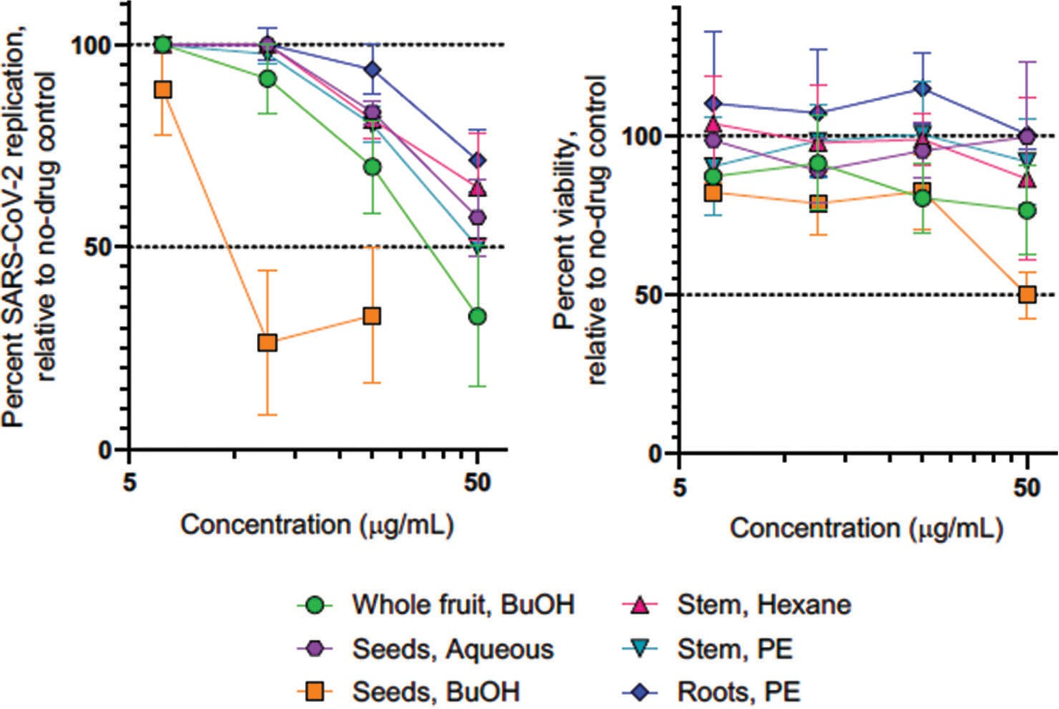

a b
Figure 3: Effects of extracts on severe acute respiratory syndrome coronavirus 2 replication in infected Vero‑E6 cells (a) and uninfected Vero‑E6 cell viability (b). All data are presented as the mean ± standard deviation from at least 2 independent experiments. BuOH: Butanol, PE: Petroleum ether

Acknowledgments
We are grateful to Mrs Christine Moore, Ms Veronica Miezah, and Mrs Cynthia Hesse for technical assistance, Christopher Abana (Department of Virology, Noguchi Memorial Institute for Medical Research, University of Ghana) for the Thp-1 cells and Bei Resources NIAID, NIH for the Leishmania donovani promastigotes (MHOM/SD/62/1S strain). We also acknowledge the support of the HIV Cure and Viral Diseases Center of The Wistar Institute, USA for the antiviral work.

References
- Salm S, Rutz J, van den Akker M, Blaheta RA, Bachmeier BE. Current
state of research on the clinical benefits of herbal medicines for
non-life-threatening ailments. Front Pharmacol 2023;14:1234701.
- Mintah SO, Archer MA, Asafo-Agyei T, Ayertey F, Jnr PA, Boamah D, et al. Medicinal plant use in Ghana: Advancement and challenges. Am J Plant Sci 2022;13:316-58.
- Fitriansyah SN, Fidrianny I, Hartati R. Pharmacological activities and phytochemical compounds: Overview of Pouteria genus. Pharmacogn J 2021;13:577-84.
- Oliveira AC, Mar JM, Corrêa RF, Sanches EA, Campelo PH, Ramos AD, et al. Pouteria spp. fruits: Health benefits of bioactive compounds and their potential for the food industry. Food Res Int 2023;173:113310.
- De Almeida R, Da Silva LL, VerÃcimo MA. Review on the therapeutic activities of the Genus Pouteria. IJAERS 2020;7:388-98.
- Altamura F, Rajesh R, Catta-Preta CM, Moretti NS, Cestari I. The current drug discovery landscape for trypanosomiasis and leishmaniasis: Challenges and strategies to identify drug targets. Drug Dev Res 2022;83:225-52.
- Rao SP, Barrett MP, Dranoff G, Faraday CJ, Gimpelewicz CR, Hailu A, et al. Drug Discovery for kinetoplastid diseases: Future directions. ACS Infect Dis 2019;5:152-7.
- Doshi RH, Nsasiirwe S, Dahlke M, Atagbaza A, Aluta OE, Tatsinkou AB, et al. COVID-19 vaccination coverage – World Health Organization African Region, 2021-2023. MMWR Morb Mortal Wkly Rep 2024;73:307-11.
- Snyman J, Sanders EJ, Ndung’u T. COVID-19 in Africa: Preexisting immunity and HIV. AIDS 2021;35:2391-3.
- Kotepui KU, Masangkay FR, De Jesus Milanez G, Kotepui M. Prevalence and outcomes of malaria as co-infection among patients with human African trypanosomiasis: A systematic review and meta-analysis. Sci Rep 2021;11:23777.
- Pikoulas A, Piperaki ET, Spanakos G, Kallianos A, Mparmparousi D, Rentziou G, et al. Visceral leishmaniasis and COVID-19 coinfection – A case report. IDCases 2022;27:e01358.
- Dofuor AK, Djameh GI, Amoa-Bosompem M, Kwain S, Osei E, Tetevi GM, et al. In vitro effects and mechanisms of action of Bidens pilosa in Trypanosoma brucei. J Tradit Complement Med 2022;12:260-8.
- Amisigo CM, Antwi CA, Adjimani JP, Gwira TM. In vitro anti‑trypanosomal effects of selected phenolic acids on Trypanosoma brucei. PLoS One 2019;14:e0216078.
- Antwi CA, Amisigo CM, Adjimani JP, Gwira TM. In vitro activity and mode of action of phenolic compounds on Leishmania donovani. PLoS Negl Trop Dis 2019;13:e0007206.

- Tietjen I, Cassel J, Register ET, Zhou XY, Messick TE, Keeney F, et al. The natural stilbenoid (-)-hopeaphenol inhibits cellular entry of SARS-CoV-2 USA-WA1/2020, B.1.1.7, and B.1.351 variants.
Antimicrob Agents Chemother 2021;65:e0077221.
- Silva CA, Melo RO, Resck IS, Silveira D. Triterpenes from Pouteria gardneri
(Mart. and Miq.) Baehni extracts. J App Pharm Sci 2016;6:197-201.
- Do TV, Suhartini W, Phan CU, Zhang Z, Goksen G, Lorenzo JM. Nutritional value, phytochemistry, health benefits, and potential food applications of Pouteria campechiana (Kunth) Baehni: A comprehensive review. J Funct Foods 2023;103:105481.
- Olszowy M. What is responsible for antioxidant properties of polyphenolic compounds from plants? Plant Physiol Biochem 2019;144:135-43.
- Park JS, Rehman IU, Choe K, Ahmad R, Lee HJ, Kim MO. A triterpenoid lupeol as an antioxidant and anti‑neuroinflammatory agent: Impacts on oxidative stress in Alzheimer’s disease. Nutrients 2023;15:3059.
- Amlabu WE, Amisigo CM, Antwi CA, Awandare GA, Gwira TM. Some novel antileishmanial compounds inhibit normal cell cycle progression of Leishmania donovani promastigotes and exhibits pro-oxidative potential. PLoS One 2021;16:e0258996.
- Shahraki S, Hosseinian S, Shahraki E, Kheirandish M, Khajavirad A. Effects of dichloromethane and N‑butanol fractions of Nigella sativa on ACHN and GP-293 cell line morphology, viability, and apoptosis. Adv Biomed Res 2023;12:200.

